Analysis of a drinking water disinfection system: an input for improving supply management in a rural aqueduct in Costa Rica
Edwin Salas-González¹, Rolando Sánchez-Gutiérrez^{1*}, Alicia Fonseca Sánchez², Carolina Alfaro Chinchilla³,Germain Esquivel-Hernández, Jorengeth Rodríguez-Rodríguez⁴, José Rodríguez-Corrales⁵
¹Water Resources Management Laboratory, School of Chemistry, Universidad Nacional, Heredia 83-3000, Costa Rica
²Environmental Hydrology Laboratory, School of Biological Sciences, Universidad Nacional, Heredia 83-3000, Costa Rica
³Waste Management Laboratory, School of Chemistry, Universidad Nacional, Heredia 83-3000, Costa Rica
⁴Microbial Biotechnology Laboratory, School of Biological Sciences, Universidad Nacional, Heredia 83-3000, Costa Rica
⁵ Laboratory of Chemical Analysis, School of Chemistry, Universidad Nacional, Heredia 83-3000, Costa Rica

*Corresponding author: rolando.sanchez.gutierrez@una.ac.cr

ORCID
Rolando Sánchez-Gutiérrez: 0000-0002-5050-021X
Jorengeth Abad Rodríguez-Rodríguez: https://orcid.org/0000-0001-8452-8256
Abstract
Disinfection is a fundamental process to ensure the quality of water for human consumption. Although currently there are multiple methodologies, chlorination has become the most widely used technique in Costa Rica due to its various advantages, as well as its great adaptability and versatility in both urban and rural communities. However, on multiple occasions, this process is conducted empirically or following general protocols that do not consider the inherent characteristics of the aqueduct (i.e. variation in flow rate, variation in concentration of ions that react with chlorine). Taking the above into consideration, this paper presents a complete assessment of the disinfection system of a rural Community-Based Water Management Organization (CBWMO) located in Santa Rosa de Poás. No similar studies have been conducted for this CBWMO. The status of the disinfection system was identified, the quality of water and the chlorine demand were determined from the source, and a series of disinfection-related recommendations and proposals were generated. The main results include a high operational and structural risk found in the disinfection systems, satisfactory compliance by most of the physicochemical parameters analyzed, and intermediate and high risk in three monitoring network sites according to IRCACH. In addition, using chlorine demand curves, a disinfection proposal for the operation of water chlorinators was prepared and presented to CBWMO administration. As a result, a series of useful inputs was provided for the operational management of the aqueduct.
Keywords
Chlorine demand, water quality, disinfection, CBWMO, residual chlorine.

Highlights
- A high operational and structural risk was found in the CBWMO disinfection systems.
- Most water quality parameters satisfactorily comply with standards.
- A disinfection proposal was prepared for the entire supply system to optimize drinking water management.

Introduction
Water is an essential resource for life. Its availability and sanitation correspond to the sixth "Sustainable Development Goal" (SDG), which aims to achieve universal, equitable, and affordable access to drinking water for the world population by 2030 (Naciones Unidas, 2024). However, the availability of this resource has been compromised due to various anthropogenic factors and as a result of the pollution of a large number of catchment sources (Du et al., 2017). In addition, according to the United Nations World Water Development Report for 2023, 2 billion people did not have access to safely managed drinking water services and 3.6 billion lacked access to safely managed sanitation (Naciones Unidas, 2023).
In the case of Costa Rica, this country has been characterized by high rates of drinking water service coverage, these rates being among the best in Latin America (Espinoza et al., 2004; Serrano et al., 2019). However, several studies have detected deficiencies in the rendering of the service, lack of planning and organization, as well as non-compliance with water quality and disinfection parameters in different supply systems (Sánchez-Gutiérrez et al., 2020a; Sánchez-Gutiérrez et al., 2020b).
Due to this problem and in order to improve access to drinking water services, alternatives such as the Community-Based Water Management Organizations (CBWMO) have helped improve coverage and quality of drinking water by having responsible water management by members of the community itself and establishing formal guidelines (Bernedo del Carpio et al., 2021; Serrano et al., 2019). In Costa Rica, there are different CBWMO models, such as Administrative Committees of Rural Aqueducts (CAARs) and Associations of Aqueduct and Sanitary Sewerage Systems (ASADASs). Both CAARs and ASADASs must be authorized by the Institute of Aqueducts and Sewers (AyA) as the country’s governing body responsible for the supply and sanitation of drinking water (Monge et al., 2013).
One of the main challenges faced by CBWMOs is water disinfection since most of these organizations are in rural areas, and the risk of contamination increases considerably with respect to urban areas (Mora-Alvarado & Portuguez, 2020). There is currently a wide variety of essential methods to eliminate different pathogenic microorganisms present in water; however, among all these methods, chlorination stands out at the national level for its usefulness, low cost, high disinfectant power, and prolonged persistence within water supply systems (Mazhar et al., 2020).
However, chlorination processes are often conducted in an improvised manner based on established protocols with a "trial and error" approach, omitting intrinsic variations of the source and other aqueduct conditions. In addition, these generalized disinfection protocols are often not consistent, which can, on one hand, cause negative health effects when the residual chlorine concentration is not optimal, and, on the other hand, promote the formation of disinfection byproducts (DBPs) or microbiological reinfections within the system (Yang & Zhang, 2016).
Therefore, the first step for optimal chlorination is to determine chlorine demand, which corresponds to the minimum dose needed in the source water to oxidize all substances in it, thus establishing more adequate and congruent dosing for each source treated (WHO, 2017). This process can work as a complement to assess the status of a disinfection system and the quality of water, in order to ensure the safety of the resource and compliance with national standards (Mora-Alvarado et al., 2018).
The supply system of a rural CBWMO in Costa Rica was analyzed in this research. This organization did not have prior studies to determine if the state of its disinfection systems directly impacted water quality. In addition, chlorine demand was studied using an in situ method that helped to determine the optimal conditions for water chlorination in the main sources of the aqueduct. Therefore, the objective of this research was to evaluate the state of the drinking water disinfection system in this rural aqueduct by determining water quality and studying the chlorine demand curve, as an input for the development of technical and administrative capacities in strengthening the management of drinking water supplies.

Methodology

Description and recognition of the study area
The Santa Rosa CBWMO is located in the canton of Poás, province of Alajuela, Costa Rica (10°6'.117"N 84°15'42.13"W). This system has 425 subscribers and caters to approximately 1,700 people. The water supply system for human consumption is made up of two non-pumping distribution subsystems with their respective disinfection systems located in the upper and lower parts of the system, together with three water springs and seven storage tanks. Figure 1 shows the general distribution of the system:
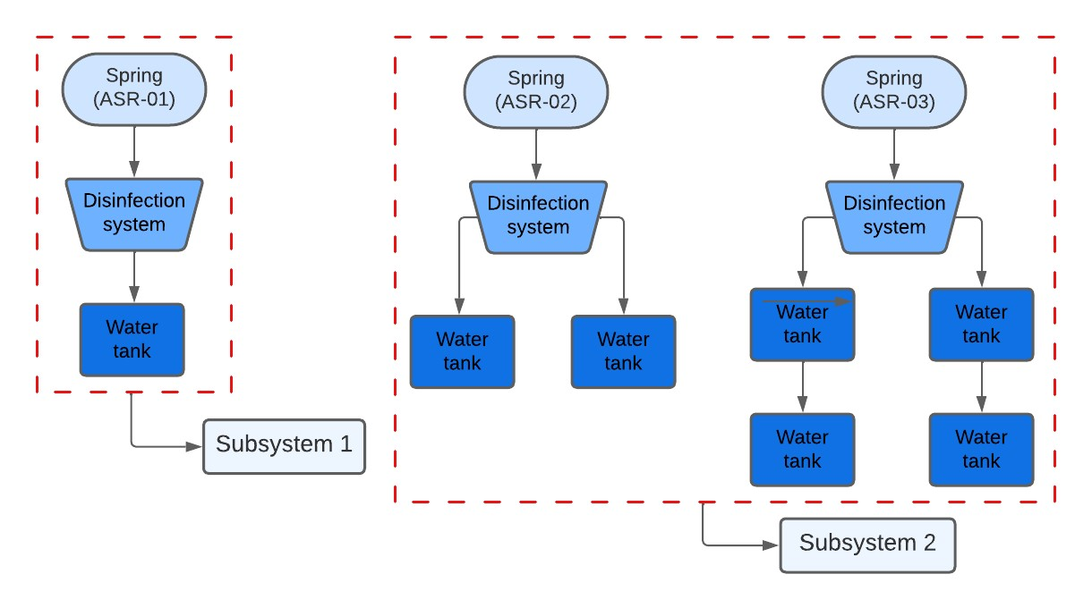
Figure 1. Flowchart of the Santa Rosa CBWMO Supply System.

Status identification of the disinfection system
Information regarding the distribution of the aqueduct was collected through structured surveys to CBWMO staff and a preliminary survey (August 2021). Additional technical information specific to the CBWMO was also consulted.
The survey instruments used were developed based on bibliographic material such as the Inspection Manual by the United States Environmental Protection Agency (US EPA) and documents issued by the World Health Organization (WHO) for water security (EPA, 2001; WHO, 2017). In addition, an adaptation of the guidelines of the Standardized Health Regulation System (SERSA) included in the Costa Rican Quality Regulations for Drinking Water (RCAP) was applied. These guidelines consist of a questionnaire on structural and operational aspects of the disinfection system and, in turn, the questionnaire assigns a rating according to the number of positive critical points found in the inspection (Gaviria-Montoya et al., 2016a; Ministerio de Salud, 2015; Villalobos, 2019).

Determining water quality
A total of 10 sample points were defined, distributed in the water sources (ASR-01, ASR-02, ASR-03), in the storage tanks (ASR-04, ASR-05, ASR-06), and in the most distant sites of the distribution network (ASR-07, ASR-08, ASR-09, ASR-10). Three sampling campaigns were conducted during the wet season (08/2021-10/2021), and a total of 30 samples were processed with more than 870 analyses between physicochemical and microbiological parameters related to water quality (Ministerio de Salud, 2015).
All samples were collected according to the specifications of method 1060 C of the Standard Methods for the Examination of Water and Waste Water (APHA, 2017). Samples were transported at a temperature below 6°C, in high density polyethylene (HDPE) plastic containers for physicochemical analysis and non-reusable sterilized vials for microbiological analysis.
Temperature, pH, conductivity, and the oxidation-reduction potential were measured in situ using a Hanna Instruments HI9829-00041 multiparameter meter (RI, USA); turbidity was measured using an Oakton T100 turbidity meter (Il, USA); and free residual chlorine and total alkalinity were measured using colorimetric methods with Hanna Instruments HI701 and HI775 checkers, respectively (RI, USA).
Total dissolved solids were determined by gravimetry at 180 °C and previously filtered with 0.45 μm filters (SMEWW 2540 C), and hardness was determined by volumetry using an EDTA standard solution (SMEWW 2340 C). Ion chromatography (Thermo ICS 5000, CA, USA) was used to analyze anions Cl⁻, Br⁻, F⁻, NO₃⁻, NO₂⁻, SO₄²⁻, as well as cations Li⁺, Na⁺, K⁺, Ca²⁺, Mg²⁺ and NH₄⁺ (SMEWW 4110 B). Minor metals (Cu, Fe, Mn, and Zn) were analyzed by air-acetylene flame atomic absorption spectrometry (SMEWW 3111 B) (Perkin Elmer AAnalyst 800, CT, USA). Finally, microbiological analyses (total coliforms and Escherichia coli) were conducted by the Microbial Biotechnology Laboratory of the School of Biological Sciences of the National University using the multiple tube fermentation technique (SMEWW 9221 E and 9223 B) with Fluorocult® medium, at a double concentration (Bartram & Ballance, 1996; Merck, 2005), quantifying the results with Table 9221 IV.

Chlorine demand analysis
Chlorine demand was analyzed in springs ASR-02 and ASR-03, the two main springs of the aqueduct that services the largest number of users. Both springs belong to subsystem 2. This analysis was carried out in 3 sampling campaigns during the wet season, as it corresponds to the most complex operating period (i.e. flow increase, increase of concentration of dissolved substances in the water). The methodology used was based on SMEWW, method 2350 B (APHA, 2017). Fresh samples were taken directly from the springs, and spiked doses of chlorine were later added with the same type of substance used by CBWMO in its system. Samples were allowed to stand for 30 minutes for the active chlorine to have the minimum contact time recommended by WHO (WHO, 2017). The chlorine concentration was later analyzed based on the 4500-Cl G method using a Hanna Instruments HI701 colorimeter (RI, USA).
The concentration of free residual chlorine vs the added doses of chlorine were plotted to obtain the respective demand curves. In addition, to ensure the homogeneity of the chlorine concentration in the system, the concentration of free chlorine was analyzed in the tanks and in the distribution network, at different times after chlorination (i.e. 2 days and 10 days). These results were contrasted using non-parametric inferential statistics.

Disinfection proposal
The disinfection proposal for CBWMO was based on the daily volume of water to be disinfected, the percentage of chlorine available from each tablet, and the concentration defined by the chlorine demand (at the level of residual chlorine concentration desired by the system operator). Thus, using equation 1, an optimal chlorine dose is established in grams:
P = $\frac{V*C_{n}}{10* \%Cl}$ (Mora, 2011)
Where:
P = Dose of chlorine added in grams
V = Volume to be disinfected for one day (L)
C_{n} = Chlorine concentration needed according to demand (mg/L)
%Cl: Percentage of chlorine in the tablets

Result analysis
To ensure the quality of the results obtained, blank samples were prepared in all analytical procedures and analyzed simultaneously with the samples. Control samples were also analyzed to verify and calibrate the equipment used. They were prepared using reference materials traceable to the National Institute of Standards and Technology (NIST). In addition, the ion balance (CBE) was calculated using an acceptable limit of ±10% as a general criterion since sample conductivities varied from 50 μS/cm to 200 μS/cm (Mageshkumar & Vennila, 2020; Sarkar & Islam, 2019).
The values obtained for each variable were compared with current national regulations (RCAP) and WHO standards (WHO, 2011) for drinking water. In addition, in order to determine the risk to people's health, the Costa Rican Drinking Water Quality Risk Index (IRCACH) (Mora-Alvarado et al., 2018) was applied in cases where there was no compliance with one or more variables according to the maximum admissible values (MAV) established by RCAP.
The descriptive and inferential statistical analysis of the measured variables was conducted using the R programming language, version 4.0.3 (R Core Team, 2022).

Results

Status of disinfection systems
For the subsystems studied, we identified the use of a Rainbow HC 3315 chlorinator (Pentair, USA), which is optimal with disinfectant tablets since it operates under the erosion principle in a humid chamber. In addition, this system is in line with the flow of the spring water (Chauca & Orozco, 2012; Pentair, 2020). ACL®90 tablets (OxyChem, USA) were used, which utilize trichloro-s-triazinetrione acid (C₃N₃O₃Cl₃) as the active ingredient, a chemical compound belonging to the family commonly referred to as chlorinated isocyanurates, and which, according to the manufacturer contain an approximate concentration of 90% of available chlorine as well as slow-dissolving tablets, suitable for these types of feeders (Pentair, 2020; Rodríguez, 2019).
According to the results derived from the instrument, it was determined that the chlorination system had been installed for more than 5 years and that, before its installation, the process was conducted in an artisanal manner with an instrument made by CBWMO. The chlorinator has been operated continuously since then, only with the initial calibration and weekly maintenance operations (adding tablets according to the recommended dose in the initial calibration, i.e. 7-8 tablets every 8 days), without additional evaluations or calibrations on its operation.
The disinfection process is conducted once a week by a trained operator, who records the number of tablets added. Handling and storage of disinfectant tablets was inadequate, as they were stored in a warehouse without the optimal and necessary ventilation and safety conditions. In addition, the operator did not use the personal protective equipment (PPE) necessary for their handling.
When applying the SERSA inspection guidelines to assess the level of infrastructural and operational risk, it was evident that both systems lack an adequate site to store chemical products and a system for their appropriate handling (i.e. chlorine tablets and use of PPE). There were no documented records of dosing flow rates and levels of free residual chlorine in tanks and distribution network or temperature and pH parameters. Derived from this instrument, 6 of the 10 possible critical points contemplated by the instrument were assigned, and both disinfection systems were classified at a high-risk level.

Physical, chemical, and microbiological parameters
Table 1 presents the results of the main physical, chemical, and microbiological parameters analyzed in contrast to the limits recommended according to the standards from Costa Rica and the World Health Organization (WHO).
Table 1. Summary of physical, chemical, and microbiological parameters of the water supply system of the Santa Rosa CBWMO.
Parameter | Unit | Mean | S.D. | Minimum | Maximum | CR^{b} | WHO^{c}
pH | - | 6.79 | 0.12 | 6.51 | 7.02 | 6.0-8.0 | 6.5-9.5
Turbidity | NTU | 0.07 | 0.26 | 0.00 | 1.38 | 5 | -
Conductivity | µS/cm | 149.4 | 43.5 | 102.0 | 255.0 | 400 | -
Temperature | °C | 20.57 | 0.95 | 19.38 | 23.81 | 30 | 25
ORP | mV | 502.4 | 185.2 | 116.3 | 706.2 | - | -
DO | mg/L | 7,44 | 1,44 | 3.83 | 9,59 | - | -
OSP | % | 95.56 | 18.78 | 49.45 | 122.05 | - | -
Free residual chlorine | mg/L | 0.27 | 0.25 | 0.02 | 0.71 | 0.3-0.6 | 5
Alkalinity | mg/L CaCO₃ | 48.6 | 6.5 | 41.5 | 68.5 | - | -
Hardness | mg/L CaCO₃ | 55.3 | 13.4 | 44.2 | 86.1 | 400 | -
TDS | mg/L | 126.1 | 24.6 | 87.0 | 178.0 | 1000 | 1000
Fluoride | mg/L | 0.061 | 0.020 | 0.049 | 0.156 | 0.7 | 1.5
Chloride | mg/L | 2.547 | 0.969 | 1.701 | 4.703 | 250 | 250
Bromideª | mg/L | - | - | - | < 0.077 | - | -
Nitriteª | mg/L | - | - | - | < 0.074 | 0.1 | -
Nitrate | mg/L | 11.061 | 8.085 | 3.136 | 28.876 | 50 | 50
Sulfate | mg/L | 5.778 | 0.866 | 5.092 | 7.717 | 250 | 500
Lithiumª | mg/L | - | - | - | < 0.024 | - | -
Sodium | mg/L | 3.977 | 0.590 | 2.975 | 4.989 | 200 | 200
Potassium | mg/L | 1.368 | 0.540 | 0.052 | 2.480 | 10 | -
Magnesium | mg/L | 5.276 | 1.447 | 4.071 | 8.494 | 50 | -
Calcium | mg/L | 13.491 | 3.122 | 10.839 | 20.327 | 100 | -
Ammoniumª | mg/L | - | - | - | < 0.031 | 0.5 | -
Copper^{to} | mg/L | - | - | - | < 0.05 | 2.0 | 2
Ironª | mg/L | - | - | - | < 0.13 | 0.3 | -
Manganeseª | mg/L | - | - | - | < 0.030 | 0.5 | 0.4
Zincª | mg/L | - | - | - | < 0.019 | 3.0 | 3
Total coliforms | MPN/100 mL | N.A. | N.A. | 0 | 80 | - | 0
E.Coli | MPN/100 mL | N.A. | N.A. | 0 | 80 | 0 | 0

Notes: S.D. Standard Deviation, ORP Oxidation-Reduction Potential, DO Dissolved Oxygen, OSP Oxygen Saturation Percent, TDS Total Dissolved Solids, MPN Most Probable Number, N.A. Not Applicable.
ª >80% of data below the limit of quantification, ^{b}Costa Rica’s RCAP (Ministerio de Salud, 2015), ^{c}World Health Organization Standards (WHO, 2011).
The mean values obtained met RCAP and international standards in all the physical parameters (pH, turbidity, conductivity, temperature, ORP, DO, and OSP), as well as in the chemical parameters (alkalinity and total hardness) (WHO, 2011; Ministerio de Salud, 2015; Sánchez-Molina et al., 2016).
In the case of free residual chlorine, it was found that of the 30 samples analyzed, 21 met the range of 0.3 mg/L to 0.6 mg/L stipulated by RCAP, mainly due to concentrations below 0.3 mg/L, increasing the risk due to microbiological contamination (Ministerio de Salud, 2015).
For the majority ionic content, anions have a distribution with the following concentration trend: HCO₃⁻ > NO₃⁻ > SO₄²⁻ > Cl⁻ > F⁻, while with cations the observed trend was as follows: Ca²⁺ > Mg²⁺ > Na⁺ > K⁺. No sample exceeded the respective limits of quantification for minority metals (Cu, Fe, Mn, and Zn); consequently, no statistical treatment was conducted.
Most of these ions did not represent a health risk or breached RCAP limits, except for nitrate anion, which although its mean value did not breach national regulations, one of the supply sources (ASR-02) consistently showed values above 25 mg/L, being a health alert according to current national standards, as well as an indicator of possible anthropogenic contamination (Chowdhury et al., 2003; Ministerio de Salud, 2015).
Finally, as part of the microbiological analysis, the presence of total coliforms (TC) and E. Coli was analyzed. Results confirmed microbiological contamination in the water from the three water springs (ASR-01, ASR-02, ASR-03), since, according to RCAP, there must be an absence of microorganisms in drinking water. Therefore, these points from where the positive samples were taken are not suitable for human consumption, evidencing the need for a chlorination system that operates in optimal conditions to ensure consumers’ health (Ministerio de Salud, 2015).

IRCACH regulatory compliance
Applying a risk index for drinking water allows us to identify that 3 of the evaluated sites present moderate and high risks to the water supply (Mora-Alvarado et al., 2018). Specifically, the variables that associate these sources with medium and high risks are the deficient amount of chlorine and the presence of microbiological contamination (E. coli). This causes negative effects on the consumer’s health and constitutes additional evidence that justifies the need to optimize the water chlorination system (Morales & Zúñiga, 2019). Figure 2 shows mean risk scores and levels obtained for each sample analyzed.

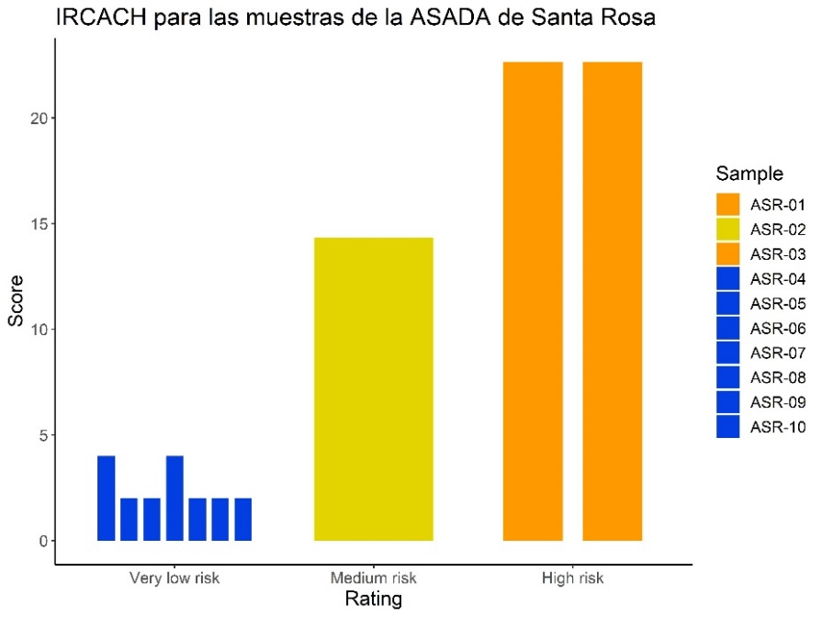
Figure 2. Risk score and classification for each sample according to IRCACH

Chlorine demand
Figure 3 shows the results obtained for the chlorine demand of the studied water springs in the three samplings conducted:
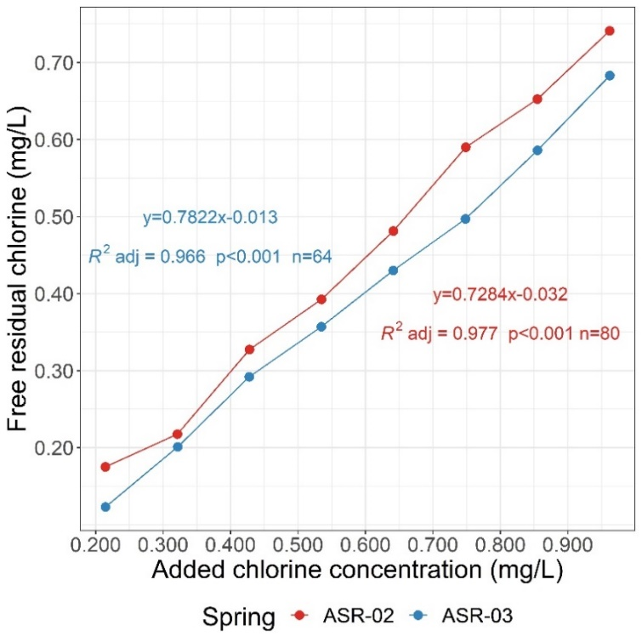
Figure 3. Chlorine demand from the ASR-02 and ASR-03 springs in the Santa Rosa CBWMO.
An increase in the concentration of residual free chlorine was observed in comparison to the initial chlorine dose, which allowed the establishment of a high correlation between both variables described by statistically significant linear regression models (p<0.001). In addition, based on the slopes of both curves, it is suggested that approximately 78% and 72% of added chlorine is converted into free residual chlorine, respectively.
It can be deduced from the above curves that the breakpoint, commonly shown by the literature, is not observed in the water sources studied. This is consistent with the low concentrations of ammonium, nitrite, iron, and manganese found, which represent an important contribution to chlorine demand (Laky & Neguez, 2024). In addition, based on the results obtained for water organoleptic characteristics, as well as DO and turbidity concentrations, it is possible to suggest low or no contents of organic matter in the water; therefore, the risk of microbiological contamination detected could be controlled with the proper management of the disinfection system.
Finally, due to the different characteristics obtained in each curve (i.e. slope, initial residual chlorine), a statistical contrast of estimated marginal means was conducted (Games et al., 1981; Searle et al., 1980) for the slopes in each curve. The above confirms that the chlorine requirements are different for each supply source, which represents a valuable finding for the proposal of individualized chlorine dosing protocols.

Variability of residual chlorine in the system
To validate the homogeneity in the concentration of residual chlorine throughout the aqueduct, the concentrations of free residual chlorine in the tanks and in the distribution networks (including the most distant sites) of the subsystem were studied, varying the post-chlorination analysis interval (i.e. 2-day and 10-day, Fig. 4). This sampling periodicity was selected to study the system under conditions of high and low concentration of free residual chlorine.
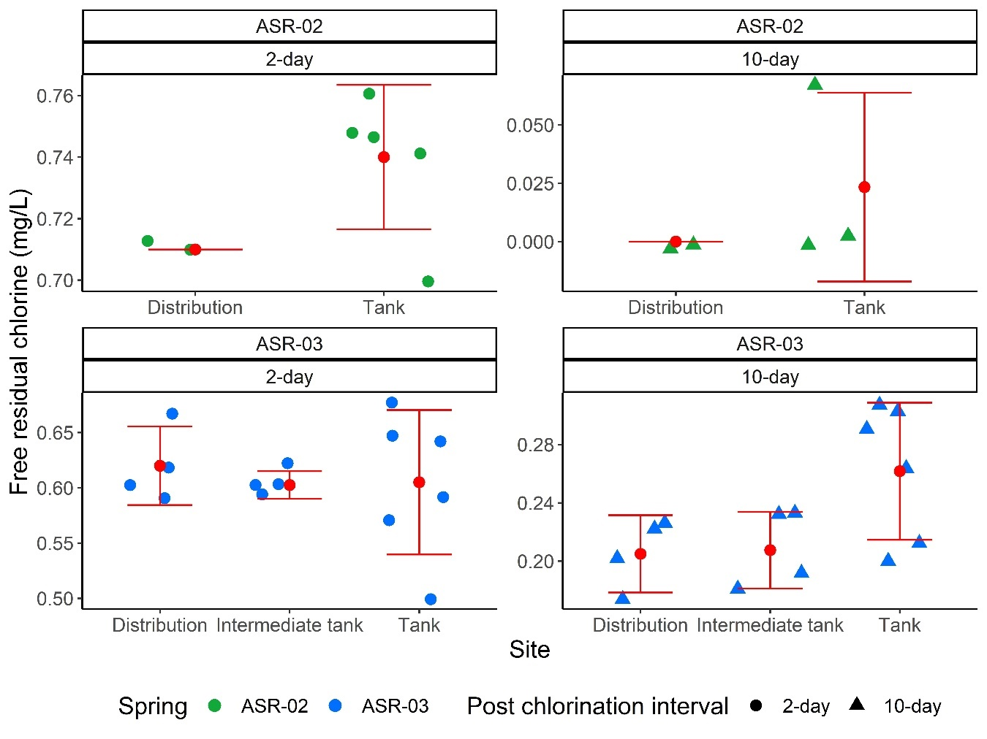
Figure 4. Behavior of residual chlorine at different points fed by springs ASR-02 and ASR-03
According to Figure 4, the mean values of free residual chlorine are slightly lower at the distribution sites compared to the values at the storage tanks. This is the case for both supply sources and both time intervals studied. However, there is no statistically significant difference between these mean values (p>0.05), which suggests a relatively homogeneous chlorine concentration for both systems. Therefore, it was not necessary to consider chlorine decay as a relevant factor in the disinfection proposal.

Disinfection proposal
Based on the suggested dose of chlorine (Fig. 3) for the desired free residual chlorine concentration levels, the number of tablets to be added to the chlorinators was estimated according to the flow rate of the supply sources. Figure 5 shows the proposed model for each source, as well as the comparison with the current scenario.
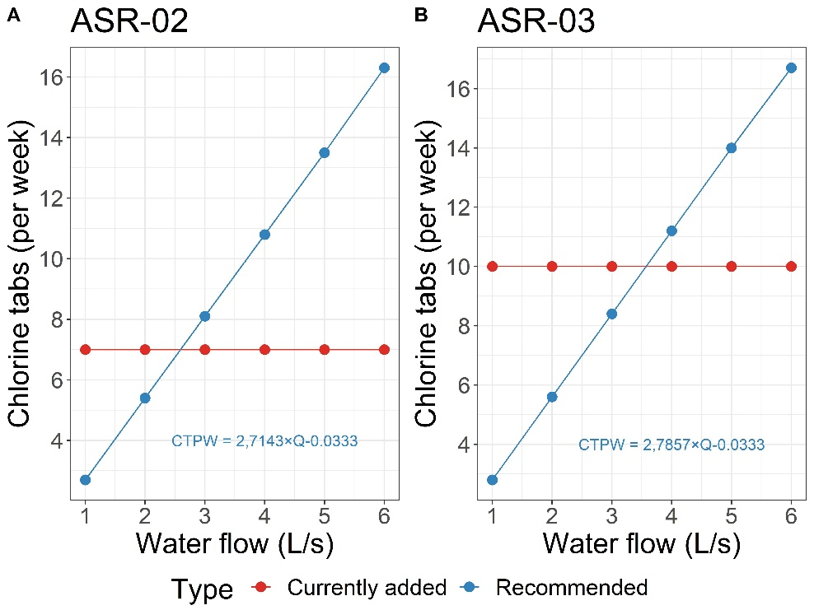
Figure 5. Comparison of suggested consumption vs. currently added consumption of tablets per week
The range of flow values used was obtained in the survey instrument applied for the identification of the disinfection system since due to the hydroclimate variations inherent to tropical areas (i.e. El Niño phenomenon), this flow can show seasonal variations for both sources. The model developed for different flow rates also shows CBWMO management that the system currently operates with the correct amounts of chlorine if the flow rates at their sources are less than 2.5 L/min and 3.5 L/min, respectively, which poses an inherent risk for the times of year (i.e. wet season) when the flow rate increases.

Results discussion

Water quality and risk index for human consumption
The concentration of free residual chlorine was outside the recommended range in most of the samples. This behavior can be attributed to the concentration differences in the system resulting from the variation of water flows, thus affecting the permanence of chlorine in the storage tanks and the distribution network (Montoya et al., 2012).
The increase in nitrate in water is usually related to human activities such as the use of fertilizers, sewers, wastewater effluents, and animal waste, due to the infiltration of fluids with high concentrations of nitrate in the soil that subsequently end up in aquifers causing contamination (Sallenave, 2017). In the case of Costa Rica, according to Sánchez-Gutiérrez et al. (2023) based on an isotopic analysis of water, decadal changes have been demonstrated in the use of soils linked to the increase of nitrate in groundwater, as well as changes in nitrate sources, with the anthropogenic pollution sources currently having the greatest contribution.
The presence of fecal coliforms (E. coli) is not allowed in water for human consumption (Ministerio de Salud, 2015). Microorganisms in water sources represent a great risk, as they are indicators of points of contamination by human activities, which in turn can contribute to contaminating groundwater, representing a risk to human health (Auquilla et al., 2005; Ordóñez-Ramírez, 2007; Mena-Rivera et al., 2018).
According to IRCACH, these three parameters are the key drivers to classifying samples ASR-01, ASR-02, and ASR-03 as intermediate and high-risk sources; therefore, water was qualified as unfit for human consumption in these sites. When other water quality indexes are reviewed such as the one from Colombia, it is observed that variables such as free residual chlorine, total coliforms, and E. coli also receive the highest possible score when they exceed the MAV because they represent a causal relationship between water quality and water-borne diseases with a high incidence (García-Ubaque et al., 2018). Therefore, chlorination has a direct impact on water quality since it decreases the level of risk at the points after disinfection stations from all sources. This also means that if the process is interrupted or an adequate dose of chlorine is not delivered, microbiological contamination can occur. Due to this, it is important to properly manage the disinfection of water springs to ensure the health of users (Zúñiga-Carrasco & Samperio-Morales, 2019).

Status of the disinfection system and chlorine demand
The erosion feeder used meets the use recommendation for 5000 people or less, due to its limited capacity to disinfect large volumes of water (AEAS, 1984; OPS, 2007). In addition, when using the online configuration, the operator can have minimal intervention, thus contributing to the automation of the process, only requiring solid chlorinated products for the proper operation of the feeder (Torres, 2019).
At the national level, these products are widely used, mainly calcium hypochlorite. However, as a result of its rapid dissolution, greater operational control is required, as well as the use of dry chamber feeders for greater process control (Mora, 2011; Vargas-Portuguez, 2021). For this reason, trichloroisocyanuric acid tablets are a better option for the operational requirements of the equipment, since unlike calcium hypochlorite, they have slow solubility; in addition, they have high percentages of active chlorine, good stability against pH and temperature variations, as well as EPA acceptance as a disinfectant in water systems for human consumption and waste (OxyChem, 2020).
The SERSA guidelines provided a real perspective of the strengths and weaknesses of the system. According to their classification, a high risk implies that actions must be taken to ensure safe operation. These actions include the development of emergency plans, community awareness, or the direct elimination of the risk factor (Ministerio de Salud, 2015). For the system studied, the following is recommended: improving dose measurements and monitoring, flow rates, and physicochemical parameters and safely storing and handling chlorine tablets to avoid their contamination and damaging the operator’s health. Finally, traceability in the use of logs and records for measurements made by the operator is suggested to establish historical databases for decision-making and future research (Gaviria-Montoya et al., 2016b; Gaviria-Montoya et al., 2016c).
Due to the shape of both curves, it is clear that no defined breakpoint was obtained in the chlorine demand similar to the one reported in the literature. However, according to other research studies conducted in drinking water with low levels of organic matter and oxidizable compounds such as iron, ammonium, manganese, and nitrites, said behavior is expected (Gómez-Soto & Payán-López, 2008; Ibarguen-Castañeda & Bernal-Mejía, 2008; Villalobos, 2019). Additionally, this trend is also observed even in waters with higher chlorine consumption, where chlorine demands of 1.55 mg/L and 1.78 mg/L are seen but have curves that follow a mostly linear trend (Perales, 2020).
However, the model obtained did not respond to a 1:1 ratio between the dose of added chlorine and the concentration of residual free chlorine, evidencing a loss in the disinfection process. Chlorine loss is due, in the first instance, to the water’s own consumption depending on the substances and other present physical conditions; however, there is also consumption due to the interface of the walls where the chlorine is contained, such as the pipes or the containers where the demand analysis was conducted (McGrath et al., 2021).
The decrease in the concentration of residual chlorine in a body of water is described by a first-order reaction, resulting from reaction kinetics that depends on the reaction time of chlorine (Walski et al., 2015). Reaction time is affected by variables such as temperature, since its solubility decreases at high temperatures, or pH, where high values disfavor the formation of hypochlorous acid, thus affecting the reaction time and directly influencing a decrease in the chlorine concentration (Ramírez-Quirós, 2005).

Optimization of operation and system maintenance
Consequently, the disinfection proposal presented to the Santa Rosa CBWMO corresponds to an operational improvement, since it is in conjunction with the monitoring of flows and routine physicochemical parameters, allows for the identification of abnormal behaviors in the processes of drinking water disinfection, and favors their correction in real-time. In addition, as observed in Figure 5, by considering the input flow to the feeder, the necessary dosing can be approximated in a simpler way in wet and dry seasons, where flows tend to increase or decrease, respectively (Villalobos, 2019). At the national level, similar methodologies have been used, where chlorine demand is determined in conjunction with other measurements such as the inflow rates of the disinfection system to evaluate the differences between the current operation of the aqueducts and the theoretical proposals (González, 2011).

In addition, a functional disinfection system ensures the quality of drinking water for users, preventing water-borne diseases, bad tastes, as well as high concentrations of disinfection by-products (Verma et al., 2017). Finally, when the chlorine dose is adjusted to the requirements of the system, disinfectant loss is avoided, which becomes a long-term economic benefit for aqueduct management. An example of this is the aqueduct of a rural community in Peru, which achieved a substantial saving of around 10% in calcium hypochlorite after the chlorine consumption optimization process was implemented (Horna, 2014).

Conclusions
The Santa Rosa CBWMO has functional disinfection systems; however, they have a high risk in terms of infrastructure and operation. At the level of water quality, most of the evaluated parameters presented satisfactory compliance with national and international standards; however, due to some indicators such as residual chlorine or the presence of pathogenic microorganisms, intermediate and high-risk levels are evident according to IRCACH, highlighting the importance of having an adequate dosage, frequency, and monitoring of the chlorination process in order to avoid compromising the health of users, as these have a direct impact on the aforementioned quality parameters.
The results of the chlorine demand allowed a first approach to the optimization of disinfection systems that had not been previously studied, thus generating specific disinfection proposals for the operating conditions, as well as a series of documents and inputs that allow strengthening water management capacities.
Finally, improving monitoring and recording aspects such as flow measurements and physicochemical parameters is recommended, in order to provide greater traceability of operating actions and be able to create a functional database that is an input for future decision making. In addition, the optimization of disinfection systems allows a substantial improvement in the management of supply water provided by the Santa Rosa CBWMO with a water security approach. This is aimed at establishing a water security plan that controls the risks at the associated critical points in the disinfection component.

Acknowledgements
We would like to thank the Santa Rosa CBWMO for allowing us to conduct this research at their facilities and for their collaboration during the sampling campaigns and to this research team for their constant companionship and support. This project was funded by the Research Office of Universidad Nacional, Costa Rica under grant SIA 0615-19. "Contribution to the integrated management of water resources in the Poás sub-basin through the generation of inputs that promote effective processes in water management" of the School of Exact and Natural Sciences of the National University of Costa Rica. Finally, we would like to express our gratitude to all student assistants and the staff of the LAMRHI-SIL, LASEQ, LHA, and Microbial Biotechnology laboratories for their support in the sampling campaigns and laboratory reports.

Disclosure statement
All authors declare no conflicts of interest.

References
APHA. (2017). Standard Methods for the Examination of Water and Wastewater. (23rd ed.). American Public Health Association.
AEAS. (1984). Manual de la Cloración. Asociación Española de Abastecimientos de Agua y Saneamiento.
Auquilla, C., Astorga, Y., & Jiménez, F. (2005). Influence of the land use in the quality of the water in the subwatershed of the river Jabonal, Costa Rica. Recursos Naturales y Ambiente, 48(48), 81–92. http://repositorio.bibliotecaorton.catie.ac.cr/bitstream/handle/11554/6408/Influencia_de_uso_del_suelo.pdf?sequence=1&isAllowed=y
Bartram, J., & Ballance, R. (1996). Water quality monitoring: a practical guide to the design and implementation of freshwater quality studies and monitoring programmes. E & FN Spon. https://doi.org/10.4324/9780203476796
Bernedo del Carpio, M., Alpízar, F., & Ferraro, P. J. (2021). Community-based monitoring to facilitate water management by local institutions in Costa Rica. Proceedings of the National Academy of Sciences of the United States of America, 118(29), e2015177118. https://doi.org/10.1073/pnas.2015177118
Chauca, C. A. F., & Orozco, C. L. S. (2012). “Diseño e Implementación de un Sistema Automatizado Para la Dosificación de cloro en el Tratamiento de Agua Potable En La Comunidad San Vicente De Lacas” [Graduate Thesis, Escuela Superior Politécnica de Chimborazo]. http://dspace.espoch.edu.ec/handle/123456789/1888
Chowdhury, S. H., Kehew, A. E., & Passero, R. N. (2003). Correlation between Nitrate Contamination and Ground Water Pollution Potential. Ground Water, 41(6), 735–745. https://doi.org/10.1111/j.1745-6584.2003.tb02415.x
Du, Y., Lv, X. T., Wu, Q. Y., Zhang, D. Y., Zhou, Y. T., Peng, L., & Hu, H. Y. (2017). Formation and control of disinfection byproducts and toxicity during reclaimed water chlorination: A review. Journal of Environmental Sciences, 58, 51–63. https://doi.org/10.1016/j.jes.2017.01.013
EPA. (2001). Manual del Inspector - Cómo Realizar Inspecciones Sanitarias en Pequeños Sistemas de Agua. Agencia de Protección Ambiental de los Estados Unidos.
Espinoza, A., Morera, A., Mora, D., & Torres, R. (2004). Calidad del agua potable en Costa Rica: Situación actual y perspectivas. Organización Panamericana de la Salud y Ministerio de Salud.
Games, P. A.; Keselman, H. J.; Rogan, J. C. Simultaneous Pairwise Multiple Comparison Procedures for Means When Sample Sizes Are Unequal. Psychol. Bull. 1981, 90 (3), 594–598. https://doi.org/10.1037/0033-2909.90.3.594.
García-Ubaque, C. A., García-Ubaque, J. C., Rodríguez-Miranda, J. P., Pacheco-García, R., & García-Vaca, M. C. (2018). Limitations of the water quality risk index as an estimator of quality for human consumption. Revista de Salud Publica, 20(2), 204–207. https://doi.org/10.15446/rsap.v20n2.65952
Gaviria-Montoya, L., Pino-Gómez, M., & Soto-Córdoba, S. (2016a). Evaluación de la gestión de la asada de Cot, Cot, Oreamuno, desde una perspectiva del uso sostenible del recurso hídrico. Centro de Investigación en Protección Ambiental.
Gaviria-Montoya, L., Pino-Gómez, M., & Soto-Córdoba, S. (2016b). Evaluación de la gestión de la ASADA de Cooperosales, San Nicolás, Cartago, desde una perspectiva del uso sostenible del recurso hídrico. Centro de Investigación en Protección Ambiental.
Gaviria-Montoya, L., Pino-Gómez, M., & Soto-Córdoba, S. (2016c). Evaluación de la gestión de la ASADA de San Isidro, San Isidro, el Guarco, desde una perspectiva del uso sostenible del recurso hídrico. Centro de Investigación en Protección Ambiental.
Gómez-Soto, A., & Payán-López, J. (2008). Evaluación de las condiciones de dosificación de clroro en la planta de tratamiento del acueducto Cestillal- El Diamante “Acucesdi” [Graduate Thesis, Universidad Tecnológica de Pereira]. https://hdl.handle.net/11059/1057
González, A. (2011). Desinfección del agua, mediante el uso del ácido tricloroisocianúrico. [Master's thesis, Instituto tecnológico de Costa Rica]. https://hdl.handle.net/2238/5666
Harris, D. C. (2007). Análisis Químico Cuantitativo. (3rd ed.). Editorial Reverté.
Horna, D. (2014). “Optimización del consumo de cloro en la potabilización del agua, haciendo uso del método del nivel estático en reservorio del sistema de agua potable rural del caserío el Tambo distrito de José Gálvez - 2014” [Graduate Thesis, Universidad Nacional de Cajamarca] https://repositorio.unc.edu.pe/bitstream/handle/20.500.14074/653/T%20628.162%20H813%202014.pdf?sequence=1&isAllowed=y
Ibarguen-Castañeda, M., & Bernal-Mejía, L. (2008). Establecer la demanda de cloro en el acueducto Tribunas Córcega de la ciudad de Pereira. [Graduate Thesis, Universidad Tecnológica de Pereira]. https://hdl.handle.net/11059/1784
Laky, D., & Neguez, S. (2024). Optimization of Breakpoint Chlorination Technologies for Drinking Water Treatment: a Hungarian Case Study. Periodica Polytechnica Civil Engineering, 3023(5), 1–12. https://doi.org/10.3311/PPci.22760
Mageshkumar, P., & Vennila, G. (2020). Assessment of errors in water quality data using ion balancing methods - A case study from Cauvery River, South India. Indian Journal of Geo-Marine Sciences, 49(1), 57–62.
Mazhar, M. A., Khan, N. A., Ahmed, S., Khan, A. H., Hussain, A., Rahisuddin, Changani, F., Yousefi, M., Ahmadi, S., & Vambol, V. (2020). Chlorination disinfection by-products in municipal drinking water – A review. Journal of Cleaner Production, 273. https://doi.org/10.1016/j.jclepro.2020.123159
Mena-Rivera, L., Vásquez-Bolaños, O., Gómez-Castro, C., Fonseca-Sánchez, A., Rodríguez-Rodríguez, A., & Sánchez-Gutiérrez, R. (2018). Ecosystemic Assessment of Surface Water Quality in the Virilla River: Towards Sanitation Processes in Costa Rica. Water, 10(7), 845. https://doi.org/10.3390/w10070845
Merck, E. (2005). Microbiology Manual, Fluoro- cult® LMX Broth Modified. Merck.
McGrath, J., Maleki, M., Bouchard, C., Pelletier, G., & Rodríguez, M. J. (2021). Bulk and pipe wall chlorine degradation kinetics in three water distribution systems. Urban Water Journal, 18(7), 512–521. https://doi.org/10.1080/1573062X.2021.1893368
Ministerio de Salud. (2015). Decreto N° 38924-S: Reglamento para la Calidad del Agua Potable. Costa Rica.
Monge, E., Paz J., L., & Ovares, C. (2013). Manual para las Asociaciones Administradoras de Sistemas de Acueductos y Alcantarillados Sanitarios (ASADAS) de Costa Rica: Transparencia y rendición de cuentas en las ASADAS. AyA.
Montoya, C., Cruz, C., Torres, P., Laín, S., & Escobar, J. (2012). Evaluación de las condiciones de mezcla y su influencia sobre el cloro residual entanques de compensación de un sistema de distribución de agua potable. Ingeniería y Ciencia, 8(15), 9–30. https://doi.org/10.17230/ingciencia.8.15.1
Mora-Alvarado, D., Orozco-Gutiérrez, J., Rivera-Navarro, P., Solís-Castro, Y., Zúñiga-Zuñiga, L., Cambronero-Bolaños, D., & García-Aguilar, J. (2018). Índice de Riesgo de la Calidad del Agua para Consumo Humano en Costa Rica (IRCACH). Revista Tecnología en Marcha, 31(3), 3-14. http://doi.org/10.18845/tm.v31i3.3897
Mora-Alvarado, D. M., & Portuguez, C. (2020). Agua para uso y consumo humano y saneamiento en costa rica al 2019: brechas y desafíos al 2023. AyA.
Mora, S. C. (2011). Evaluación de las principales tecnologíás utilizadas en Costa Rica para la desinfección de agua. [Licentiate's thesis, Universidad de Costa Rica]. http://repositorio.sibdi.ucr.ac.cr:8080/jspui/handle/123456789/3096
Morales, S. H., & Zúñiga, C. I. R. (2019). Importancia de la cloración del agua: sitios de abastecimiento con presencia de bacterias patógenas. ENF INF MICROBIO, 39(3), 86–92. https://www.medigraphic.com/cgibin/new/resumen.cgi?IDARTICULO=92252
Muñoz, M., Venegas, R., Brenes, J., Torres, K., Siles, G., & Alvarado, R. (2020). Estudio técnico de capacidad hídrica e hidráulica del acueducto de Santa Rosa, Poás. Hidrotec Internacional Tecnología Líquida S.A.
Naciones Unidas. (March 26, 2024). Objetivos de desarrollo sostenible. un.org. https://www.un.org/sustainabledevelopment/es/objetivos-de-desarrollo-sostenible/
Naciones Unidas. (2023). Informe Mundial de las Naciones Unidas sobre el Desarrollo de los Recursos Hídricos 2023: Alianzas y cooperación por el agua. Unesco.
OPS. (2007). Guía para la selección de sistema de Desinfección. Organización Panamericana de la Salud.
Ordóñez-Ramírez, V. (2007). Contaminación del agua. Ingenius, 20(1), 1–3. https://doi.org/10.17163/ings.n1.2007.04
OxyChem. (2020). SALES SPECIFICATION ACL ® 90 Disinfecting Tablets. OxyChem.com http://sds.oxy.com/private/document.aspx?prd=M44626~~PDF~~MTR~~ANSI~~EN~~2013-03-01 13:37:37.0~~ACL® 90 DISINFECTING TABLETS
Pentair. (2020). MODEL 300/320 AUTOMATIC CHLORINE/BROMINE FEEDERS. Pentair.com. https://www.pentair.com/content/dam/extranet/nam/pentair-pool/residential/sanitizers/chlorine-bromine-feeders/Rainbow-300320-ChlorineBromine-Feeders-English.pdf
Perales, E. (2020). Determinación de la dosificación óptima de cloro en relación con cloro residual en el tratamiento de agua para consumo en la Urbanización Santa Lucia - Morales. [Graduate Thesis, Universidad Peruana Unión]. http://hdl.handle.net/20.500.12840/4252
Ramírez-Quirós, F. (2005). Tratamiento de Desinfección del Agua Potable. Canal Educa. https://www.fundacioncanal.com/canaleduca/wp-content/uploads/2015/08/Tratamiento-de-desinfeccion-del-agua-potable2.pdf
Rodríguez, I. R. (2019). Proyecto constructivo del sistema de abastecimiento de agua a la comunidad de matapalo en el sur pacífico de Costa Rica. [Master's thesis, Universidad Politécnica de Madrid]. https://oa.upm.es/55530/
Sallenave, R. (2017). Nitrate in Drinking Water. New Mexico State University. http://aces.nmsu.edu/pubs/_m/M112.pdf
Sánchez-Gutiérrez, R., Mena-Rivera, L., Sánchez-Murillo, R., Fonseca-Sánchez, A., & Madrigal-Solís, H. (2020a). Hydrogeochemical baseline in a human-altered landscape of the central Pacific coast of Costa Rica. Environmental Geochemistry and Health, 42(9), 2685–2701. https://doi.org/10.1007/s10653-019-00501-5
Sánchez-Gutiérrez, R., Benavides-Benavides, C. Chaves-Villalobos, M., & Quirós-Vega, J. (2020b). Calidad del agua para consumo humano en una comunidad rural: caso Corral de Piedra, Guanacaste, Costa Rica. Revista Tecnología en Marcha, 33, 3–16. https://doi.org/10.18845/tm.v33i2.4165
Sánchez-Gutiérrez, R., Sánchez-Murillo, R., Esquivel-Hernández, G., Birkel, C., Boll, J., Rojas-Jiménez, L. D., & Castro-Chacón, L. (2023). Nitrate Legacy in a Tropical and Complex Fractured Volcanic Aquifer System. Journal of Geophysical Research: Biogeosciences, 128(8). https://doi.org/10.1029/2023JG007554
Sánchez-Molina, V., Solís-Montiel, E., Valdés-González, J., Fernández-Araya, J., Coto-Campos, J., & Mendelewicz-Goldwaig, M. (2016). Química analítica experimental. EUNA.
Sarkar, B., & Islam, A. (2019). Assessing the suitability of water for irrigation using major physical parameters and ion chemistry: a study of the Churni River, India. Arabian Journal of Geosciences, 12(20). https://doi.org/10.1007/s12517-019-4827-9
Searle, S. R.; Speed, F. M.; Milliken, G. A. Population Marginal Means in the Linear Model: An Alternative to Least Squares Means. Am. Stat. 1980, 34 (4), 216–221. https://doi.org/10.1080/00031305.1980.10483031.
Serrano, A. S., Garro, Á. B., Sanabria, G. D., Conejo, J. R., Cantillano, D. R., & Watson, A. G. (2019). Seguridad hídrica: Gestión del agua en comunidades rurales del Pacífico Norte de Costa Rica. Revista de Ciencias Ambientales, 53(2), 25–46. https://doi.org/10.15359/rca.53-2.2
Torres, A. C. A. (2019). Diseño de un sistema automatizado para la dosificación de cloro en el tratamiento de agua potable en el distrito de Huambos [Graduate thesis, Universidad César Vallejo]. https://hdl.handle.net/20.500.12692/38844
Vargas-Portuguez, M. D. (2021). “Evaluación de tecnologías de cloración mediante sistemas de pastillas y cloro líquido controlado con ORP en agua para consumo humano.” [Licentiate's Thesis, Instituto Tecnológico de Costa Rica]. https://hdl.handle.net/2238/13310
Verma, K., Gupta, A. B., & Singh, A. (2017). Optimization of chlorination process and analysis of THMs to mitigate ill effects of sewage irrigation. Journal of Environmental Chemical Engineering, 5(4), 3540–3549. https://doi.org/10.1016/j.jece.2017.07.002
Villalobos, M. M. (2019). Evaluación y propuesta de mejora del sistema de abastecimiento de agua potable de la ASADA Paquera de Puntarenas. [Licentiate's Thesis, Tecnológico de Costa Rica]. https://hdl.handle.net/2238/11163
Walski, T., Helsel, E., Strickland, C., & Whitman, B. (2015). Decay of disinfectant residual in overland flow. Urban Water Journal, 12(8), 639–645. https://doi.org/10.1080/1573062X.2014.939091
WHO. (2011). Guías para la calidad del agua de consumo humano. World Health Organization.
WHO. (2017). Principles and Practices of Drinking-water Chlorination. World Health Organization.
Yang, M., & Zhang, X. (2016). Current trends in the analysis and identification of emerging disinfection byproducts. Trends in Environmental Analytical Chemistry, 10, 24–34. https://doi.org/10.1016/j.teac.2016.03.0023
Zúñiga-Carrasco, I. R., & Samperio-Morales, H. (2019). Importancia de la cloración del agua: sitios de abastecimiento con presencia de bacterias patógenas. Enfermedades Infecciosas y Microbiologia, 39(3), 86-92.

