Haplotypes of Aedes aegypti and Aedes albopictus larvae detected in 18 districts of Costa Rica

Edwin Beltre-Nuñez ^{* 1}, Sonia Flores-Nuñez ¹, Silvia Arguello ¹, Antony Solorzano-Morales ², Gaby Dolz ^{1,2}

1 Master's degree in Tropical Diseases, Regional Postgraduate in Tropical Veterinary Sciences at National University
2 Laboratory of Zoonoses and Entomology, Population Medicine Program, School
Veterinary Medicine, National University

Background:
There are approximately 3,500 species of mosquitoes distributed on all continents except Antarctica. Some of these species are important since they transmit diseases (Aguirre & Navarro, 2017). Aedes aegypti and Aedes albopictus belong to the Culicidae family of the Diptera order and are biological vectors of more than 26 viruses, including dengue virus, chikungunya virus and Zika virus, impacting public health and posing an economic burden on hospitals, especially in tropical and subtropical regions (Cadavid et al., 2015; McKenzie et al., 2019). Approximately two-fifths of the global population are at risk of contracting dengue fever, and an estimated 500,000 people are affected by hemorrhagic disease annually, with mortality rates exceeding 20% (Guo et al., 2016; Hemme et al., 2010). The chikungunya virus can also present as hemorrhagic disease; it also causes meningoencephalitis and myocarditis (Arredondo et al., 2016), whereas Zika causes severe joint pain, Guillain–Barré syndrome and congenital anomalies such as microcephaly (Plourde & Bloch 2016).
Traditional strategies for the control of vectors that transmit arboviruses include the application of insecticides and elimination of containers with standing water to avoid oviposition by mosquitoes(Marín et al., 2014; Zheng et al., 2018). In Costa Rica, pyrethroid insecticides (deltamethrin and cypermethrin) and organophosphates (temephos) are used in fumigation campaigns (Calderón et al., 2018). New control measures include the release of sterile insects and the replacement of the population with transgenic mosquitoes incapable of transmitting arboviruses (Hemme et al., 2010).
Aedes control programs seek to reduce the density of the adult mosquito population below a critical threshold where epidemic transmission is unlikely to occur (Hemme et al., 2010). For this reason, it is essential to understand dispersal patterns, propagation in the environment and the factors that facilitate the adaptation of mosquitoes to new environments. It is hypothesized that genetic changes in insects could play a role in the adaptation of mosquitoes to new environments, which is why it is important to study the genetic diversity of these mosquitoes (Bennett et al., 2016).
Studies of genetic variation in Aedes species have been based on investigations of various regions of mitochondrial DNA (Heredia & Lira, 2013; Mousson et al., 2005), with the mitochondrial gene encoding cytochrome oxidase I (COI) being one of the most common genes studied to show linear evolution and a relatively fast rate of evolution (Futami et al., 2015).
The first genetic studies of Aedes showed little genetic variation and clustering of populations by continent or country (Black et al., 1988; Kambhampati et al., 1991; Oliveira et al., 2003), but recently, different haplotypes have been established in populations. of Aedes in the same continent or country (Gupta & Preet, 2014; Kamgang et al., 2013; Usmani et al., 2009).
Moreover, studies carried out in Italy have revealed different haplotypes of Aedes albopictus associated with tropical or temperate regions (Shaikevich & Talbalaghi, 2013), whereas Cameroon populations of Aedes. albopictus are related to specimens originating in tropical zones rather than temperate or subtropical zones (Kamgang et al., 2011). In Senegal, domestic populations of Aedes aegypti tend to have less genetic diversity and variation than jungle populations do (Huber et al., 2008), whereas in Cambodia, little genetic diversity is found in populations of Aedes aegypti due to natural factors (habitat availability) and human factors (insecticide use) (Urdaneta-Marquez & Failloux, 2011).
In Costa Rica, the diversity of Aedes albopictus in a population of adult mosquitoes in the district of La Virgen, Sarapiquí, is high (seven haplotypes) (Futami et al., 2015). Gloria-Soria et al. (2018) conducted a comparative study of Aedes aegypti mosquitoes from the United States of America, Mexico and Costa Rica and reported two haplotypes in the Siquirres district (haplotypes A and G). This study aimed to investigate the genetic diversity of Aedes aegypti and Aedes albopictus in 18 districts of Costa Rica.

Methods:

Type of study and sample collection
A cross-sectional and descriptive study was carried out in which larvae of Aedes aegypti and Aedes albopictus at all stages (L1-L4) were collected by researchers at the Directorate of Vector Surveillance of the Ministry of Health of Costa Rica between August and November 2021. The larvae were collected from the streets and sidewalks of 26 locations in 18 districts located less than 900 m above sea level; they were selected at random. We collected 100 ml of water and dumped the contents of the hatchery, filtered the water with a fine mesh strainer and then introduced the larvae into a plastic bottle containing water. In cases where hatcheries were large or impossible to move, the larvae were captured by passing the strainer inside the container or with the help of plastic Pasteur pipettes. The larvae were placed in containers with water from the hatchery and were transported alive to the laboratory, where they were immediately identified.

Taxonomic identification of the larvae
Taxonomic identification of the larvae was carried out using morphological indicators described by Rueda (2004), the thorax and eighth abdominal segment were visualized using a stereoscope and, once identified, only one larvae from each district (18) was selected due to budget constraints and was frozen at -20 °C until subsequent DNA extraction.

DNA extraction
DNA was extracted from the larvae using a QIAamp DNA Mini Kit (Qiagen, Germany) following the manufacturer's recommendations. The extracted DNA quality was measured with a NanoDrop One spectrophotometer (Thermo Fisher Scientific, USA) and subsequently stored at -20 °C until analysis by molecular testing.

Polymerase chain reaction (PCR)
The protocol described by Escobar et al. (2022) was used to amplify a 710 bp region of the cytochrome oxidase I (COI) gene of Aedes aegypti. The initiators used were LCO1490 (5´-GGTCAACAAATCATAAAGATATTGG-3´) and HCO2198 (5´-TAAACTTCAGGGTGACCAAAAATCA-3´). First, a reaction mixture consisting of 25 µL of DreamTaqTM Master Mix (2x) (Thermo Fisher Scientific, USA), 17 µL of nuclease-free water (Thermo Fisher Scientific, USA), 2 µL of each primer (10 µM), and 4 µL of DNA was prepared. The cycling conditions were as follows: an initial cycle at 95 °C for 10 min; 37 cycles at 94 °C for 1 min, 48 °C for 1 min, and 72 °C for 1 min; and a final cycle at 72 °C for 7 min. For Aedes albopictus, the protocol described by Zhong et al. (2013) involves amplification of a 1390 bp fragment of the COI gene using two pairs of overlapping primers: albo1454F (5′ GGTCAACAAATCATAAAGATATTGG 3′), albo2160R (5′ TAAACTTCTGGATGACCAAAAAATCA 3′) and albo2027F (5′ CCCGTATTAGCCGGAGCTAT 3′)′ We used 25 µL of DreamTaq™ Master Mix (2x) (Thermo Fisher Scientific, USA), 18.5 µl of nuclease-free water (Thermo Fisher Scientific, USA), 2 µl of each primer (10 µM) and 2.5 µl of DNA. The thermal cycler conditions were as follows: initial denaturation at 94 °C for 3 min, followed by 35 cycles at 94 °C for 30 sec, 55 °C for 30 sec, and 72 °C for 1 min, and a final extension at 72 °C for 6 min. The amplicons were subjected to 1% agarose gel electrophoresis with GelRed (Biotium, USA) and visualized on a transilluminator (Analytik Jena, Germany).

Sequencing and haplotype analysis
The products amplified via PCR were sent to Macrogen Company (Seoul, South Korea) for sequencing. The sequences obtained were edited with the BioEdit 7.2.5 program (Hall 1999), multiple alignment was performed by ClustalW (Thompson et al. 1994), the mutation sites were determined, and the amino acid sequences were determined. In addition, the sequences were compared with the sequences available in the GenBank database using the NCBI program BLAST (Basic Local Alignment Search Tool) (http://www.ncbi.nlm.nih.gov/BLAST/) to verify that they corresponded with known Aedes aegypti and Aedes albopictus sequences with a nucleotide similarity percentage greater than 99%. The MEGA 10.1.8 program (Kumar et al. 2018) was used to plot the unweighted pair group arithmetic average (UPGMA) (Sneath & Sokal, 1973) tree on the basis of Tajima‒Nei's genetic distance (Tajima & Nei, 1984). The percentage of replicate trees in which the associated taxa clustered together in the bootstrap test (10000 replicates) is shown next to the branches (Felsenstein, 1985).

Results
Aedes aegypti was found in all districts, and Aedes albopictus was found in 11 of the 18 included districts. The analysis of 18 Aedes aegypti (one per district) revealed three genetic variants, the H1, H2 and H4 haplotypes (Table 1). The H1 haplotype was the most abundant and the one with the greatest distribution, found in 14 districts, whereas the H2 and H4 haplotypes were found in one and three districts, respectively (Table 1, Figure 1A). On the other hand, the 11 larvae of Aedes albopictus included five genetic variants, namely, haplotypes H3, H6, H26, H37 and H67. The most abundant haplotype was H67, which was found in five districts, and H37, which was found in three districts. The remaining haplotypes were each found in only one district. Table 2 compares the haplotypes of Aedes aegypti and Aedes albopictus found in the different districts of Costa Rica in 2021 with reports of the same haplotypes detected in other countries.
Table 1. Haplotypes of Aedes aegypti and Aedes albopictus found in 18 districts of Costa Rica in 2021.
District | Locality | Haplotypes Aedes aegypti | Haplotypes  Aedes albopictus | Geographic coordinate
 |  |  |  | Length: | Latitude
Buenos Aires | Buenos Aires | H1 | H37 | -83,204331 | 9,94525923
Daniel Flores | Conception | H1 | H6 | -83,683834 | 9,37194
San Isidro de El General | San Isidro de El General | H1 | H3 | -83,708781 | 9,374551
Chomes | Morales Point | H1 | H37 | -84,945572 | 10,072762
Tarcoles | Blue Beach | H1 | H37 | -84,633717 | 9,775853
Old port | Orange grove 2 | H1 | H67 | -83,986452 | 10,452357
The virgin | The Chilera | H1 | H26 | -84,6108727 | 10,26541
Cairo | Cairo | H1 | H67 | -83,532904 | 10,119598
Guacimo | Afriquita | H1 | H67 | -83,4010031 | 10,1290357
Guápiles | The Diamonds | H1 | H67 | -83,774632 | 10,211391
Rita | Rita | H1 | H67 | -83,776214 | 10,265982
Pital | Pital | H4 | NE * | -84.275609 | 10.449463
Jaco | Jaco | H1 | NE | -84.6269457 | 9.6273826
The Isabel | La Mora | H2 | NE | -83.676245 | 9.915485
The Switzerland | The Switzerland | H1 | NE | -83.609574 | 9.849404
Pavones | Link | H1 | NE | -83.641261 | 9.880263
Turrialba | The Carmen Lira | H4 | NE | -83.676715 | 9.913490
Siquirres | San Rafael | H4 | NE | -83.5082671 | 10.1047255
* NE: No Aedes. albopictus in the district.

Table 2. Comparison of the haplotypes of Aedes aegypti and Aedes albopictus found in different districts of Costa Rica in 2021 with reports of haplotypes detected in other countries and the GenBank access code, nucleotide identity and percentage of identity of these haplotypes.
Aedes aegypti
District | Haplotype | GenBank reference | Country | Nucleotide identity | Percentage of identity (%)
Buenos Aires | H1 | ON100811 | Honduras | 494/494 | 100%
Daniel Flores
San Isidro de El General
Chomes
Tarcoles
Jaco
The Switzerland
Pavones
Old port
The virgin
Cairo
Guacimo
Guápiles
Rita
 | H1 | MK028227-MK028228 | El Salvador | 483/483 | 100%
 | H1 | MK028230-MK028232 | El Salvador | 483/483 | 100%
 | H1 | MK028240-MK028242 | El Salvador | 483/483 | 100%
 | H1 | MK028256 | El Salvador | 483/483 | 100%
 | H1 | MK028258-MK028260 | El Salvador | 483/483 | 100%
The Isabel | H2 | KX171389-KX171390 | Panama | 471/471 | 100%
Pital | H4 | MF443395-MF443397 | Canada | 650/650 | 100%
Siquirres | H4 | MF043259 |  | 650/650 | 100%
Turrialba | H4 | KY022526 | Germany, | 650/650 | 100%
 | H4 | MN733746-MN733753 | New Caledonia | 650/650 | 100%
 | H4 | MN733743, MN733745 | New Caledonia | 650/650 | 100%
 | H4 | ON100786-ON100795 | Honduras | 494/494 | 100%
 | H4 | ON100797-ON100810 | Honduras | 494/494 | 100%
 | H4 | ON100812-ON100813 | Honduras | 494/494 | 100%
 | H4 | ON100815-ON100816 | Honduras | 494/494 | 100%
 | H4 | MK028219-MK028220 | El Salvador | 483/483 | 100%
 | H4 | MK028222-MK028226 | El Salvador | 483/483 | 100%
 | H4 | MK028229, MK028231 | El Salvador | 483/483 | 100%
 | H4 | MK028235-MK028239 | El Salvador | 483/483 | 100%
 | H4 | MK028244-MK028245 | El Salvador | 483/483 | 100%
 | H4 | MK028248, MK028250 | El Salvador | 483/483 | 100%
 | H4 | MK028254, MK028261 | El Salvador | 483/483 | 100%
 | H4 | MG241352 | Costa Rica | 575/575 | 100%
 | H4 | KX171394 | Panama | 471/471 | 100%
Aedes albopictus
District | Haplotype | GenBank reference | Country | Nucleotide identity | Percentage of identity (%)
San Isidro de El General | H3 | KC690898.1 | Japan | 1390/1390
San Isidro de El General | H3 | KC690898.1 | China | 1390/1390
San Isidro de El General | H3 | KC690898.1 | Taiwan | 1390/1390 | 100%
San Isidro de El General | H3 | KC690898.1 | Italy | 1390/1390
San Isidro de El General | H3 | KC690898.1 | USA | 1390/1390
Daniel Flores | H6 | KX886307.1 | China | 542/542 | 100%
The virgin | H26 | KC690921.1 | Singapore | 1390/1390 | 100%
Buenos Aires  Chomes  Tarcoles | H37* | KC690932.1 | Italy |  | 100%
Buenos Aires  Chomes  Tarcoles | H37* | KC690932.1 | USA |  | 100%
Buenos Aires  Chomes  Tarcoles | H37* | KC690932.1 | Costa Rica Panama | 1317/1317 | 100%
Old port  Cairo  Guacimo  Guápiles  Rita | H67* | AB907796.1 | Costa Rica |  | 100%
 |  |  |  | 1390/1390 | 100%
* Haplotype previously reported in Costa Rica.

When the COI gene sequences of the 3 haplotypes of Aedes aegypti were analyzed, four sites, two sites and nine polymorphic sites were found in the H1, H2 and H4 haplotypes, respectively (Table 3A), with the amino acid sequence affecting the polymorphic sites at positions 168, 246 and 579. At position 168, H1 encoded a methionine, whereas H2 and H4 encoded isoleucine. At position 246, H1 and H2 encode methionine, H4 encodes isoleucine, H79 encodes H1, H2 encodes isoleucine, and H4 encodes methionine (Table 4A). The H3, H26, H37 and H67 haplotypes of Aedes albopictus presented a polymorphic site in their sequences, whereas the H6 haplotype presented two polymorphic sites (Table 3B). The amino acid sequence of the polymorphic sites was established at positions 40 and 94. At position 40, H6 encoded a phenylalanine, while the rest of the haplotypes encoded an isoleucine, and at position 94, H67 encoded an isoleucine, while the rest encoded valine (Table 4B). The phylogenetic tree based on the sequence of the COI I gene established 3 well-defined clades for Aedes aegypti (Figure 2) and five well-defined clades for Aedes albopictus, presenting a clade for each haplotype (Figure 3).

Table 3. Polymorphic sites of the haplotypes of Aedes aegypti (A) and Aedes albopictus (B) from Costa Rica found in the sequences of the COI gene.
To
Aedes aegypti | Polymorphism position
Haplotype | 33 | 168 | 234 | 237 | 246 | 318 | 330 | 351 | 435 | 480 | 501 | 579 | 618 | 630 | 636
H1 | T | G | T | C | G | A | A | T | G | G | C | A | T | G | C
H2 | T | A | T | C | G | A | G | C | A | A | C | A | C | G | C
H3 | C | A | C | T | A | G | G | C | G | A | T | G | T | A | T
B
Aedes albopictus | Polymorphism position
Haplotype | 40 | 94 | 467 | 954 | 1140 | 1404
H3 | A | G | T | A | C | G
H6 | T | G | C | - | - | -
H26 | A | G | T | A | T | A
H37 | A | G | T | G | T | G
H67 | A | A | T | A | T | G

Table 4. Polymorphisms with amino acid changes in different haplotypes of Aedes aegypti (A) and Aedes albopictus (B) from Costa Rica according to the COI gene sequence.
A
Aedes aegypti | Change position in amino acids
Haplotype | 168 | 246 | 579
H1 | Methionine | Methionine | Isoleucine
H2 | Isoleucine | Methionine | Isoleucine
H3 | Isoleucine | Isoleucine | Methionine
B
Aedes albopictus | Change position in amino acids
Haplotype | 40 | 94 | -
H3 | Isoleucine | Valine | -
H6 | Phenylalanine | Valine | -
H26 | Isoleucine | Valine | -
H37 | Isoleucine | Valine | -
H67 | Isoleucine | Isoleucine | -

To
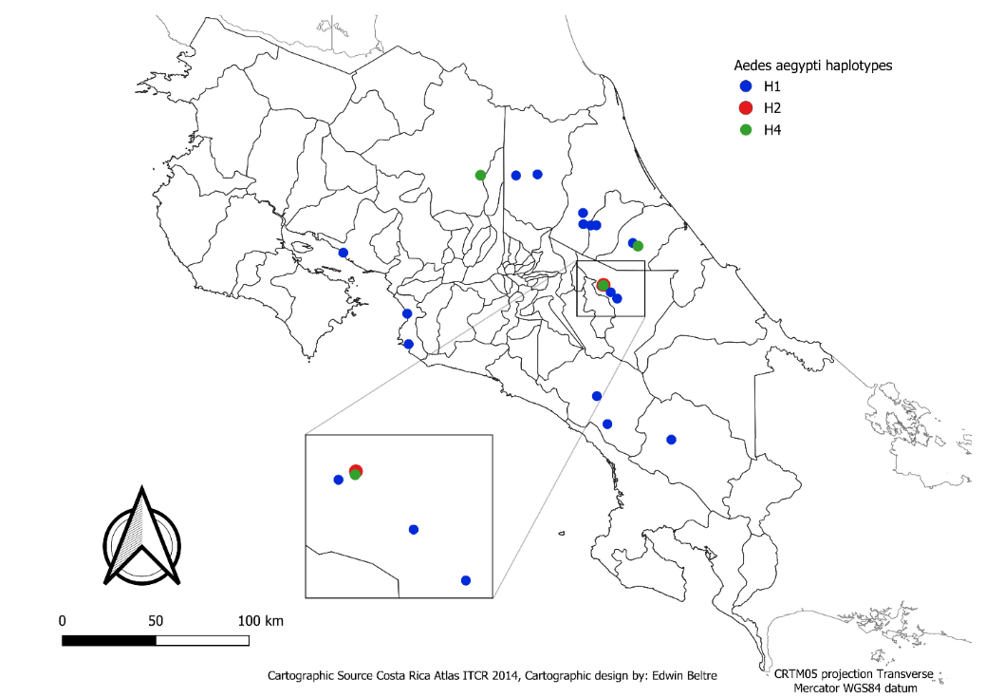

B
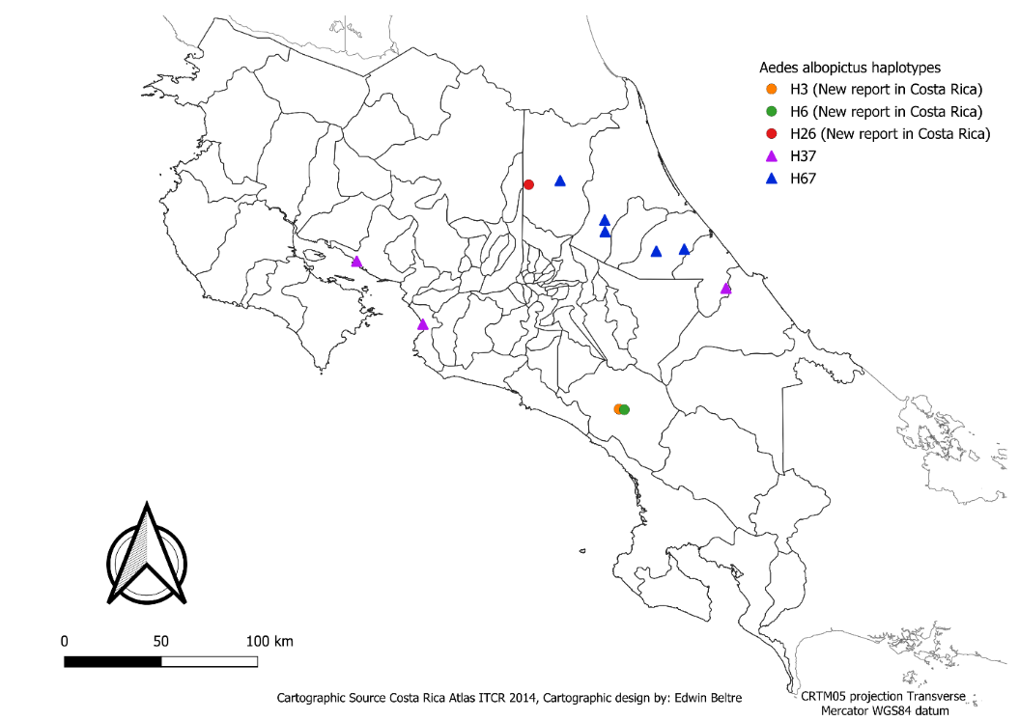
Fig. 1. Distribution map of the haplotypes of Aedes aegypti (1A) and Aedes albopictus (1B) found in 18 and 11 districts of Costa Rica, respectively, in 2021.

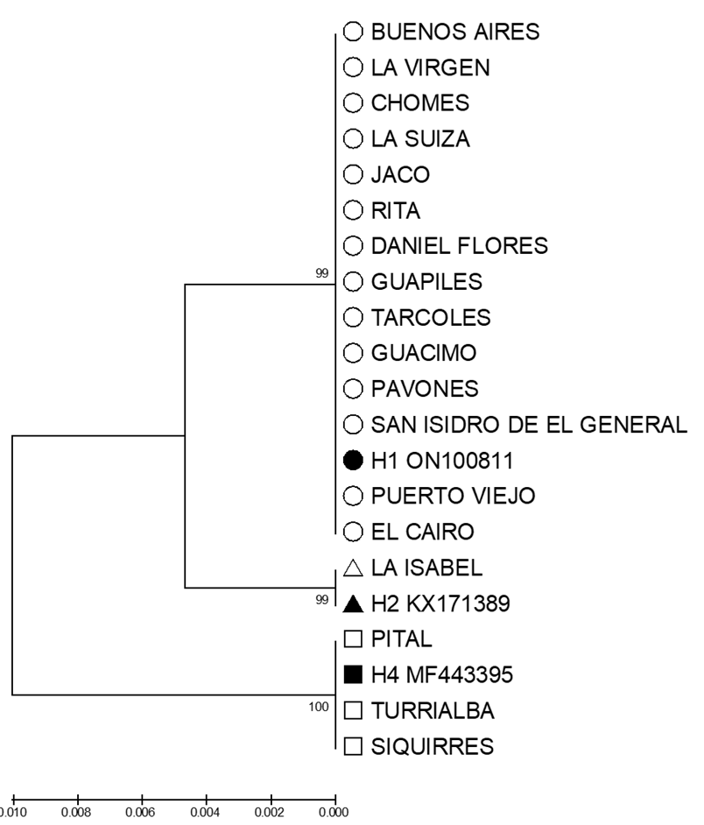
Fig. 2. Dendrogram obtained from a 650-nucleotide fragment of the COI gene of Aedes aegypti constructed using the UPGMA method. Three reference strains of Aedes Aegypti and the haplotypes found in the present study are shown.

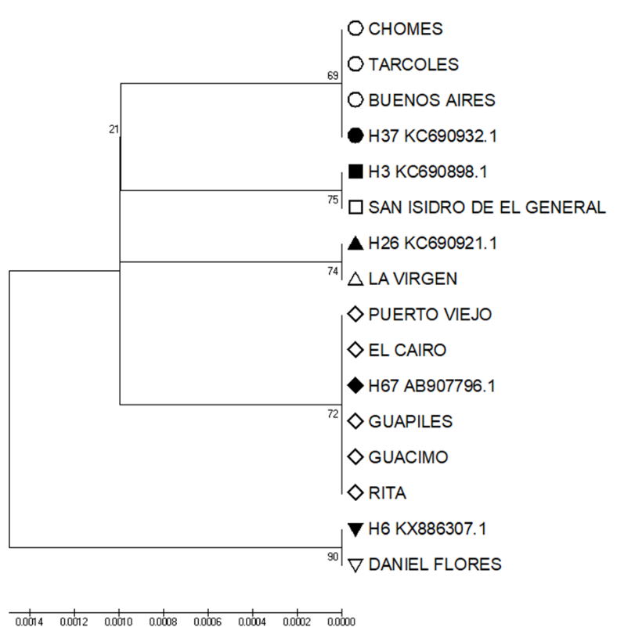
Figure 3. Dendrogram obtained from a 1007-nucleotide fragment of the COI gene of Aedes albopictus constructed using the UPGMA method. Five reference strains of Aedes Albopictus and the haplotypes found in the present study are shown.

Discussion

The number of haplotypes of Aedes aegypti (n = 8) determined using a total of 18 larvae collected from 18 locations in Costa Rica was similar to that reported in El Salvador (10 haplotypes in a total of 84 samples) and Panama (13 haplotypes in a total of 122 samples), and these larvae were collected from six and 30 locations, respectively (Joyce et al., 2018; Eskildsen et al., 2018). Compared with these reports, numerous Aedes aegypti larvae with different haplotypes were detected, although only one larva of each species was analyzed in each district due to economic limitations. In Aedes albopictus, the number of haplotypes detected in a small number of larvae (5 haplotypes in 11 larvae) was similar to reported in Brazil (10 haplotypes in 163 samples from 14 localities) (Scarpassa et al., 2008) and in Colombia (33 haplotypes in 163 samples and 87 haplotypes in 145 samples from 14 and six locations, respectively) (Cadavid et al., 2015; Gómez et al., 2022). This could be due to the climatic and geographical similarities between Costa Rica and the countries of Central and South America; if more larvae are collected in different regions of Costa Rica, greater diversity may be found (Cadavid et al., 2015).

Two haplotypes of Aedes aegypti (H1 and H2) and three haplotypes of Aedes albopictus (H3, H6 and H26) that had not been previously found in Costa Rica were reported in this study. Each of these haplotypes was detected in only one district, except for haplotype 1 of Aedes aegypti, which was widely distributed in a total of 14 districts (Barrientos & Chávez, 2008). This haplotype has also been reported in El Salvador, where it is also the most widely distributed haplotype in all the departments of that country (Joyce et al., 2018). Likewise, in Honduras, it is the most abundant and widespread haplotype (Joyce et al., 2024). Haplotype 2 Aedes aegypti was found only in the La Isabel district in the southern central region of the country and had been previously reported in Panama (Eskildsen et al., 2018). Haplotype 3 Aedes aegypti was found in three districts (Pital, Siquirres and Turrialba) and has already been reported previously in the Siquirres district (Gloria-Soria et al., 2018). In contrast, with haplotypes 1 and 2 of Aedes aegypti, which have only been reported to date in El Salvador, Honduras and Panama, haplotype 4 has also been found in countries such as Canada, New Caledonia and Germany, in addition to Central America.
Haplotypes 3 and 6 of Aedes albopictus were found in the southern districts of the country and have been previously reported only in Japan, Italy, the U.S. (H3) and China (H6), whereas a third newly discovered haplotype (H26) of Aedes albopictus was found in the northern districts of the country and has been previously reported in Singapore. The other two haplotypes detected (H37 and H67) had previously been found in the district of La Virgen in Sarapiquí. (Futami et al., 2015). In the present study, H37 was found to be distributed in the Pacific and Atlantic areas of the country, whereas H67 was found to be more widely distributed, but only in the Atlantic area. Our findings agree with those of Futami et al. (2015), who reported a high diversity of haplotypes of Aedes albopictus (7 haplotypes) in La Virgen de Sarapiquí. We found an additional haplotype in the same district, reporting for the first time the presence of H26 in La Virgen. In studies carried out in Medellín, Colombia, different haplotypes were determined in three neighborhoods and two time periods (January–April 2010 and October–December 2012), and the results revealed that the genetic composition changes without a predictable pattern in a 2-year period (Cadavid et al., 2015).

Conclusion
Systematic studies with multiple larvae from each district in the dry and rainy seasons are recommended to determine the haplotypes present in the different seasons. This analysis would increase the understanding of the genetic diversity, speed of reproduction and genetic flow of natural mosquito populations. These analyses provide not only an evolutionary perspective on vector populations but also a key tool for designing and optimizing control strategies that can slow the spread of diseases transmitted by arbovirus vectors.

