Supplementary figure

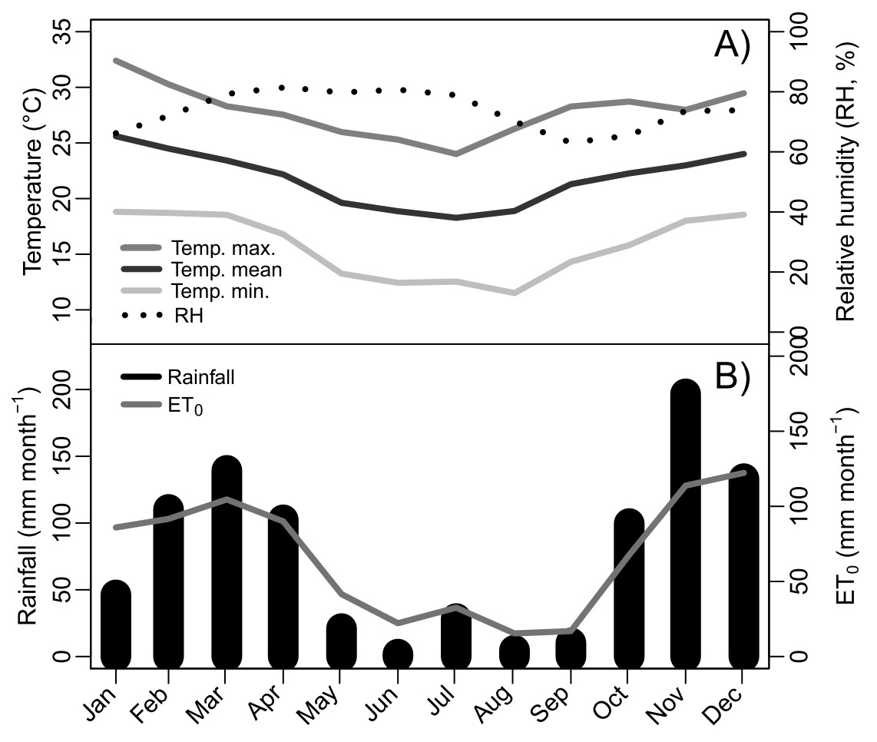
Fig. S1. Meteorological data. Monthly weighted averages from January to December/2015 at Matas de Minas region. A) air temperature and relative humidity; and B) rainfall and potential evapotranspiration (ET₀). Data compiled from three meteorological station: Caparaó (83639-Station Number), Caratinga (83592-Station Number), and Viçosa (83642-Station Number) from the Matas de Minas region. Database source: INMET-Brazil.

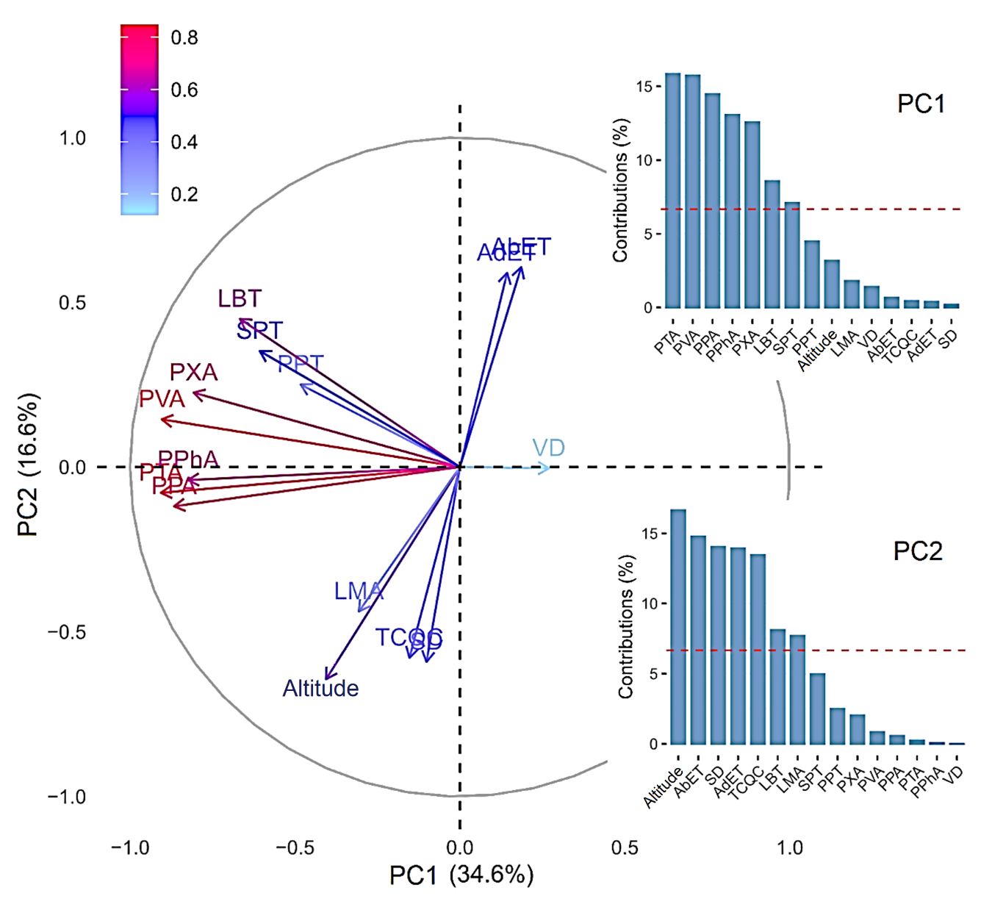
Fig. S2. The first two axes of a principal component (PC) analysis for coffee cup quality and morphoanatomical leaf features. Subplots are shown contributions of variables to PC. Total quality (TCQC), Stomata density (SD, n mm⁻²), Leaf mass per area (LMA, g m⁻²), Venation density area (VD, mm mm⁻²), Petiole area, cross section (PTA, mm⁻²), Petiole vascular tissue area, cross section (PVA, mm⁻²), Petiole parenchyma area, cross section (PPA, mm⁻²), Petiole xylem area, cross section (PXA, mm⁻²), Petiole phloem area, cross section (PPhA, mm⁻²), Leaf blade thickness (LBT, μm), Epidermis, adaxial face (AdET, μm), Palisade parenchyma (PPT, μm), Lacunar (spongy) parenchyma (SPT, μm), and Epidermis, abaxial face (AbET, μm).

